
QUALITY ALERT

Customer: Golden Date: January 29, 2022
Die: 15602 Colour: WH -141
Type of Complaint: Golden Reject

Q.A # Q.I.R # CUSTOMER NCR #

Description: Customer rejects due to OUT-OF-SHAPE pieces that cannot go into the punch, and flex collapses due to being THIN and SMALL.
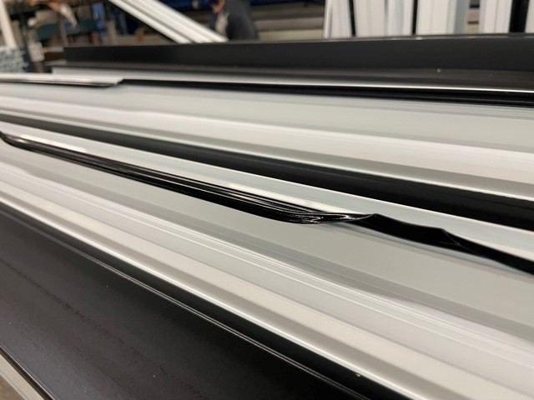
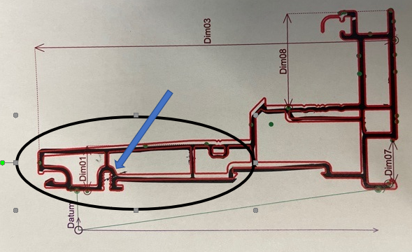

BY SIGNING BELOW, YOU ACKNOWLEDGE THE PROBLEM ABOVE AND AGREE TO MONITOR THIS ISSUE IN FUTURE PRODUCTION RUNS.
DAY SHIFT |  | AFTERNOON SHIFT |  | NIGHT SHIFT
NAME | SIGNATURE | NAME | SIGNATURE | NAME | SIGNATURE

